HTS_TST and TX_NEW
HTS Cascade
- Total Tested
Indicator | DATIM_Indicator | Element Result Froup
HTS_INDEX Community | HTS_INDEX_COM_N_DSD_Age_Sex_Result | New Negatives, Newly Tested Positives
HTS_INDEX TA | HTS_INDEX_FAC_N_TA_Age_Sex_Result | New Negatives, Newly Tested Positives
HTS_TST TA | HTS_TST_N_TA_Inpat_Age_Sex_Result | Positives, Negatives
HTS_TST TA | HTS_TST_N_TA_OtPITC_Age_Sex_Result | Positive, Negative
HTS_TST TA | HTS_TST_N_TA_PMTCT_PB_Age_Sex_Result | Positive, Negative
HTS_TST TA | HTS_TST_N_TA_PMTCT_PP_LandD_Age_Sex_Result | Positive, Negative
HTS_TST TA | HTS_TST_N_TA_SNS_Age_Sex_Result | Positive, Negative
HTS_TST TA | HTS_TST_N_TA_STI_Age_Sex_Result | Positive, Negative
PMTCT_STAT(NUM) TA | PMTCT_STAT_N_TA_Age_Sex_KnownNewResult | New Positives and New Negatives
TB_STAT(NUM) TA | TB_STAT_N_TA_Age_Sex_KnownNewPosNeg | New Positives and New Negatives

- Total Positive – just take Positives on (i)
- Initiations
Indicator | DATIM_Indicator
TX_NEW TA | TX_NEW_N_TA_Age_Sex_HIVStatus

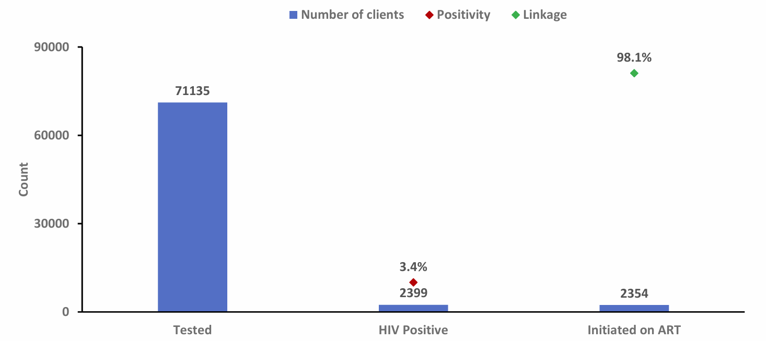

HIV Testing Trends
- Case finding tests
Indicator | DATIM_Indicator | Element Result Froup
HTS_INDEX Community | HTS_INDEX_COM_N_DSD_Age_Sex_Result | New Negatives, Newly Tested Positives
HTS_INDEX TA | HTS_INDEX_FAC_N_TA_Age_Sex_Result | New Negatives, Newly Tested Positives
HTS_TST TA | HTS_TST_N_TA_Inpat_Age_Sex_Result | Positives, Negatives
HTS_TST TA | HTS_TST_N_TA_OtPITC_Age_Sex_Result | Positive, Negative
HTS_TST TA | HTS_TST_N_TA_SNS_Age_Sex_Result | Positive, Negative
HTS_TST TA | HTS_TST_N_TA_STI_Age_Sex_Result | Positive, Negative
TB_STAT(NUM) TA | TB_STAT_N_TA_Age_Sex_KnownNewPosNeg | New Positives and New Negatives

HIV Testing and Positivity Trends
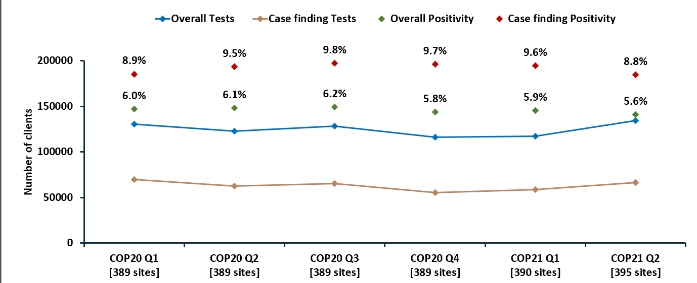

HIV Testing by Province (can be filtered to facility level)

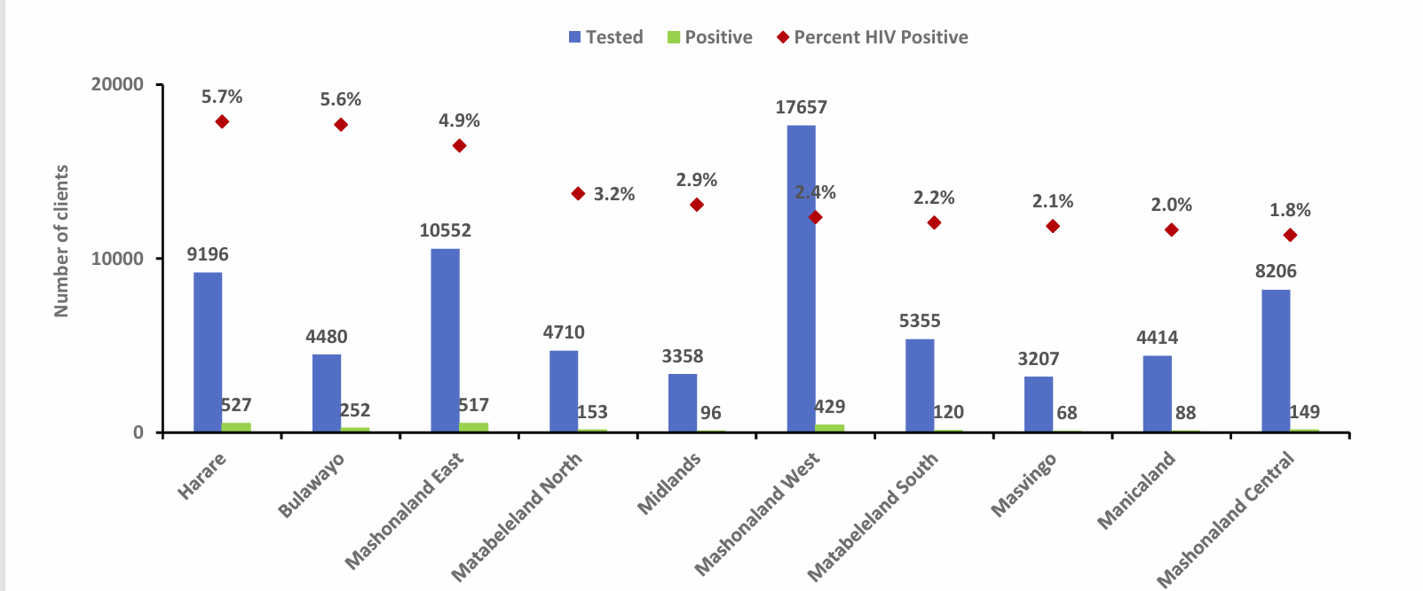

HIV Testing by Modality
Modality | DATIM_Indicator | Element Result Froup
Community Index | HTS_INDEX_COM_N_DSD_Age_Sex_Result | New Negatives, Newly Tested Positives
Facility Index | HTS_INDEX_FAC_N_TA_Age_Sex_Result | New Negatives, Newly Tested Positives
Inpatient | HTS_TST_N_TA_Inpat_Age_Sex_Result | Positives, Negatives
Other PITC | HTS_TST_N_TA_OtPITC_Age_Sex_Result | Positive, Negative
Post Breast feeding | HTS_TST_N_TA_PMTCT_PB_Age_Sex_Result | Positive, Negative
Labour and Delivery | HTS_TST_N_TA_PMTCT_PP_LandD_Age_Sex_Result | Positive, Negative
SNS | HTS_TST_N_TA_SNS_Age_Sex_Result | Positive, Negative
HTS_TST TA | HTS_TST_N_TA_STI_Age_Sex_Result | Positive, Negative
ANC1 | PMTCT_STAT_N_TA_Age_Sex_KnownNewResult | New Positives and New Negatives
TB | TB_STAT_N_TA_Age_Sex_KnownNewPosNeg | New Positives and New Negatives

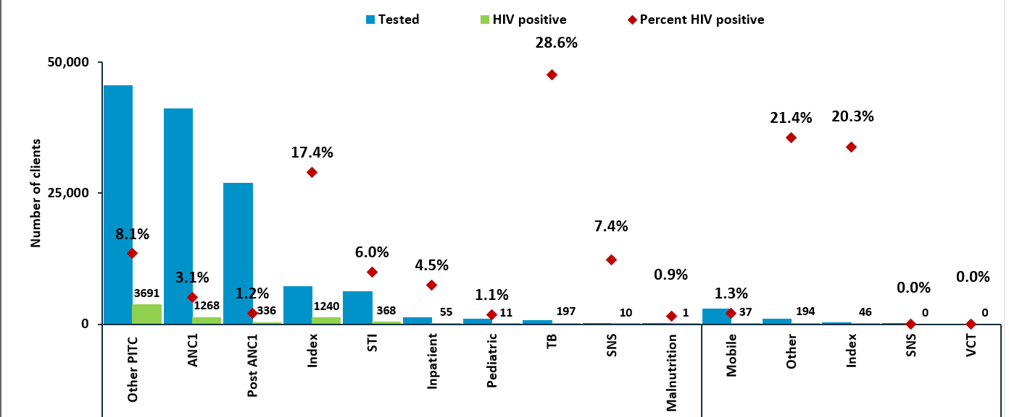
HIV Testing by Sex
Indicator | DATIM_Indicator | Element Result Froup | Element Gender
HTS_INDEX Community | HTS_INDEX_COM_N_DSD_Age_Sex_Result | New Negatives, Newly Tested Positives | Male, Female
HTS_INDEX TA | HTS_INDEX_FAC_N_TA_Age_Sex_Result | New Negatives, Newly Tested Positives | Male, Female
HTS_TST TA | HTS_TST_N_TA_Inpat_Age_Sex_Result | Positives, Negatives | Male, Female
HTS_TST TA | HTS_TST_N_TA_OtPITC_Age_Sex_Result | Positive, Negative | Male, Female
HTS_TST TA | HTS_TST_N_TA_PMTCT_PB_Age_Sex_Result | Positive, Negative | Male, Female
HTS_TST TA | HTS_TST_N_TA_PMTCT_PP_LandD_Age_Sex_Result | Positive, Negative | Male, Female
HTS_TST TA | HTS_TST_N_TA_SNS_Age_Sex_Result | Positive, Negative | Male, Female
HTS_TST TA | HTS_TST_N_TA_STI_Age_Sex_Result | Positive, Negative | Male, Female
PMTCT_STAT(NUM) TA | PMTCT_STAT_N_TA_Age_Sex_KnownNewResult | New Positives and New Negatives | Male, Female
TB_STAT(NUM) TA | TB_STAT_N_TA_Age_Sex_KnownNewPosNeg | New Positives and New Negatives | Male, Female

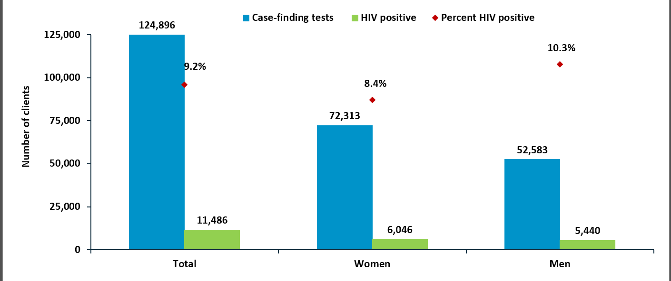
HIV Testing by Age and Sex
Indicator | DATIM_Indicator | Element Result Froup | Element Age | Element Gender
HTS_INDEX Community | HTS_INDEX_COM_N_DSD_Age_Sex_Result | New Negatives, Newly Tested Positives | Grouped Ages | Male, Female
HTS_INDEX TA | HTS_INDEX_FAC_N_TA_Age_Sex_Result | New Negatives, Newly Tested Positives | Grouped Ages | Male, Female
HTS_TST TA | HTS_TST_N_TA_Inpat_Age_Sex_Result | Positives, Negatives | Grouped Ages | Male, Female
HTS_TST TA | HTS_TST_N_TA_OtPITC_Age_Sex_Result | Positive, Negative | Grouped Ages | Male, Female
HTS_TST TA | HTS_TST_N_TA_PMTCT_PB_Age_Sex_Result | Positive, Negative | Grouped Ages | Male, Female
HTS_TST TA | HTS_TST_N_TA_PMTCT_PP_LandD_Age_Sex_Result | Positive, Negative | Grouped Ages | Male, Female
HTS_TST TA | HTS_TST_N_TA_SNS_Age_Sex_Result | Positive, Negative | Grouped Ages | Male, Female
HTS_TST TA | HTS_TST_N_TA_STI_Age_Sex_Result | Positive, Negative | Grouped Ages | Male, Female
PMTCT_STAT(NUM) TA | PMTCT_STAT_N_TA_Age_Sex_KnownNewResult | New Positives and New Negatives | Grouped Ages | Male, Female
TB_STAT(NUM) TA | TB_STAT_N_TA_Age_Sex_KnownNewPosNeg | New Positives and New Negatives | Grouped Ages | Male, Female

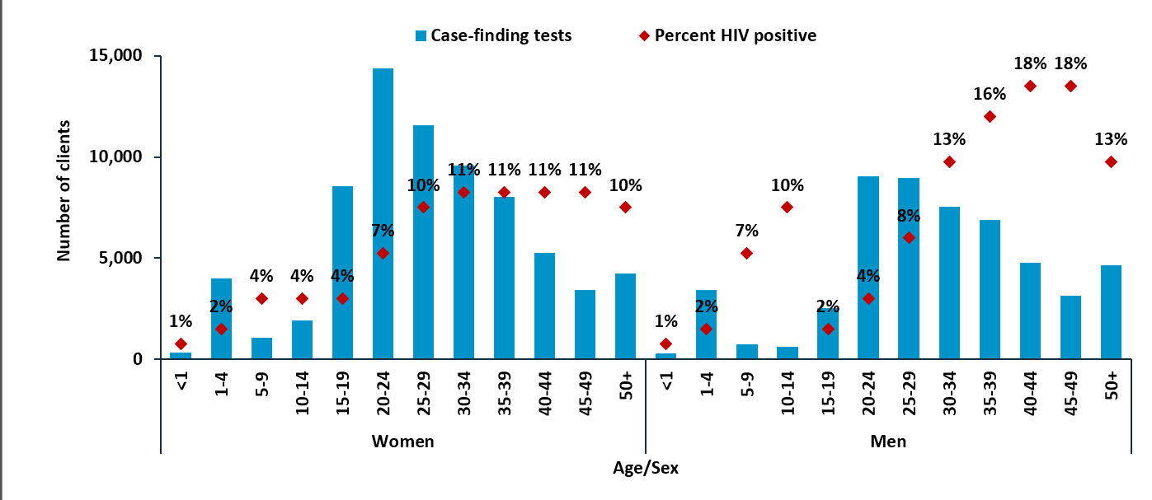

ART LINKAGE by PROVINCE
- Total Initiations/Total tests by province etc
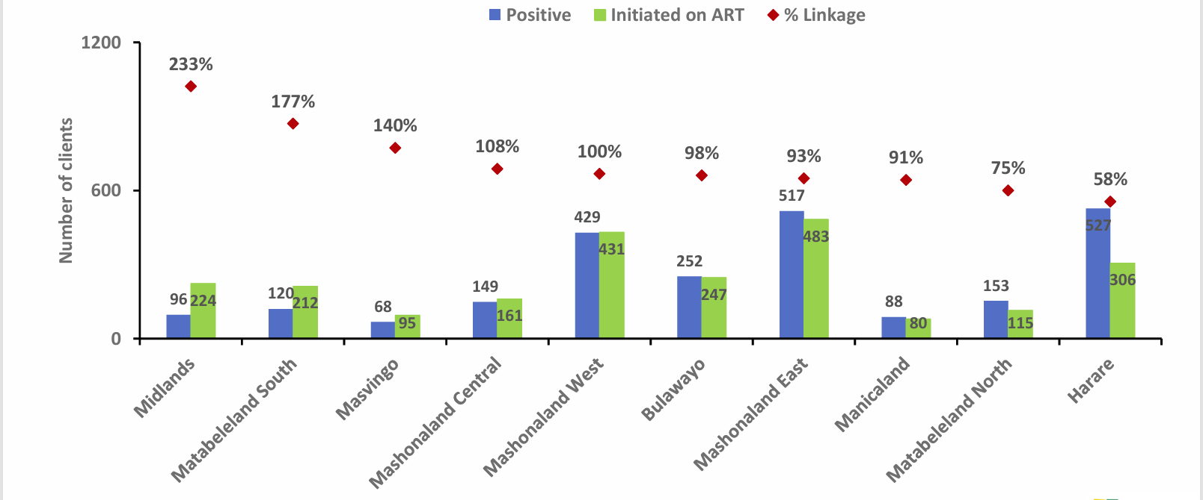
ART LINKAGE by Age

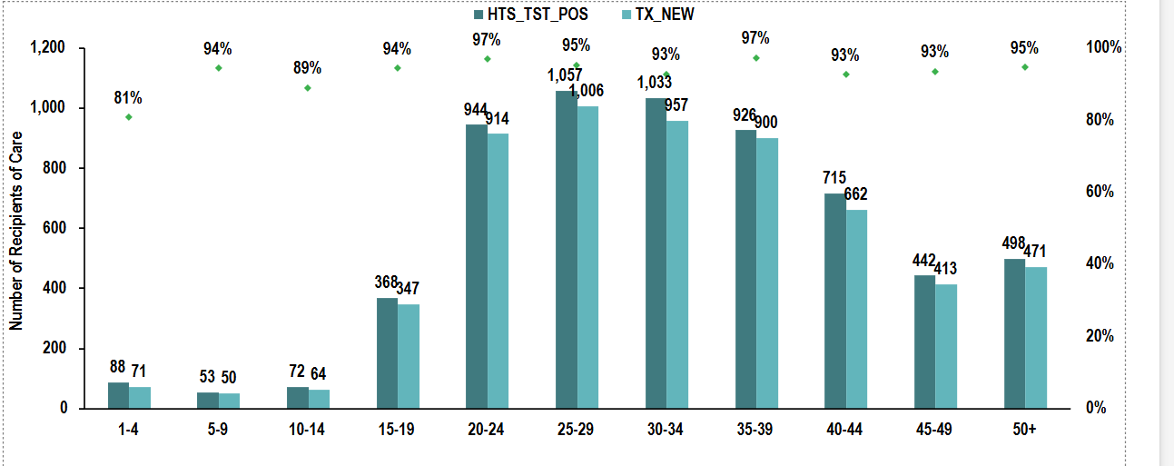

PMTCT_EID and PMTCT_HEI
Early Infant diagnosis Cascade
HIV Positive mothers
Indicator | DATIM_Indicator | Element Result Group
HTS_TST TA | HTS_TST_N_TA_PMTCT_PB_Age_Sex_Result | Positive
HTS_TST TA | HTS_TST_N_TA_PMTCT_PP_LandD_Age_Sex_Result | Positive
PMTCT_STAT(NUM) TA | PMTCT_STAT_N_TA_Age_Sex_KnownNewResult | New Positives and Known Positives

HIV Exposed Infants tested
Indicator | DATIM_Indicator | Element Age
PMTCT_EID TA | PMTCT_EID_N_TA_Age_EID | <= 2 months, 2 - 12 months

HIV Positive Infants
Indicator | DATIM_Indicator | Element Result Group
PMTCT_HEI TA | PMTCT_HEI_N_TA_Age_Result | Positive

Infants Initiated on ART
Indicator | DATIM_Indicator | Element Modality
PMTCT_HEI_POS TA | PMTCT_HEI_POS_N_TA_Age_HIVStatus_ART | Receiving ART

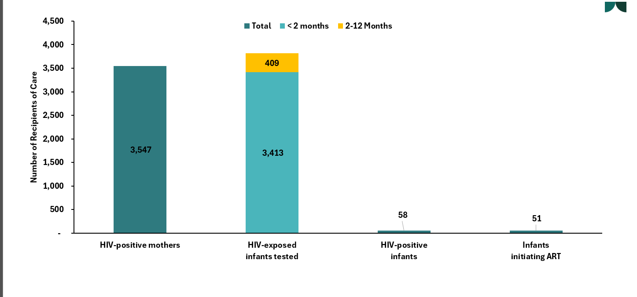

EID testing by age at sample collection
Indicator | DATIM_Indicator | Element Modality | Element Age
PMTCT_EID TA | PMTCT_EID_N_TA_Age_EID | EID First Test, EID Second Test | <= 2 months, 2 - 12 months

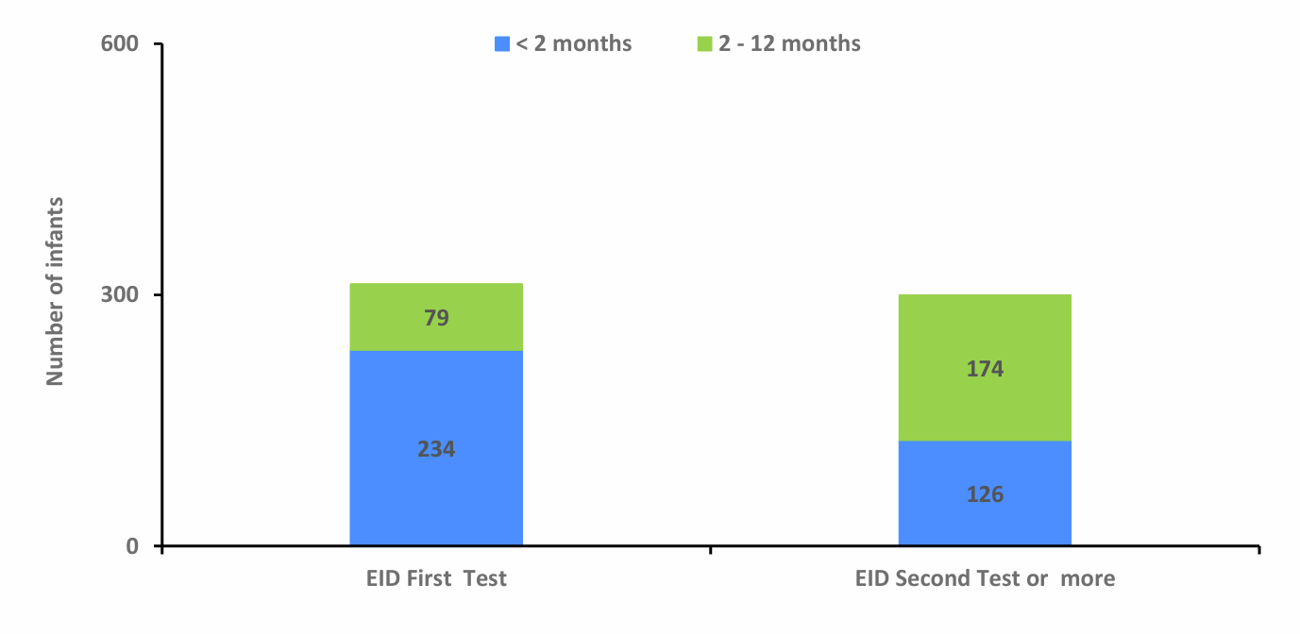
EID results by age at sample collection
Indicator | DATIM_Indicator | Element Result Group | Element Age
PMTCT_HEI TA | PMTCT_HEI_N_TA_Age_Result | Positive, Negative | <= 2 months, 2 - 12 months

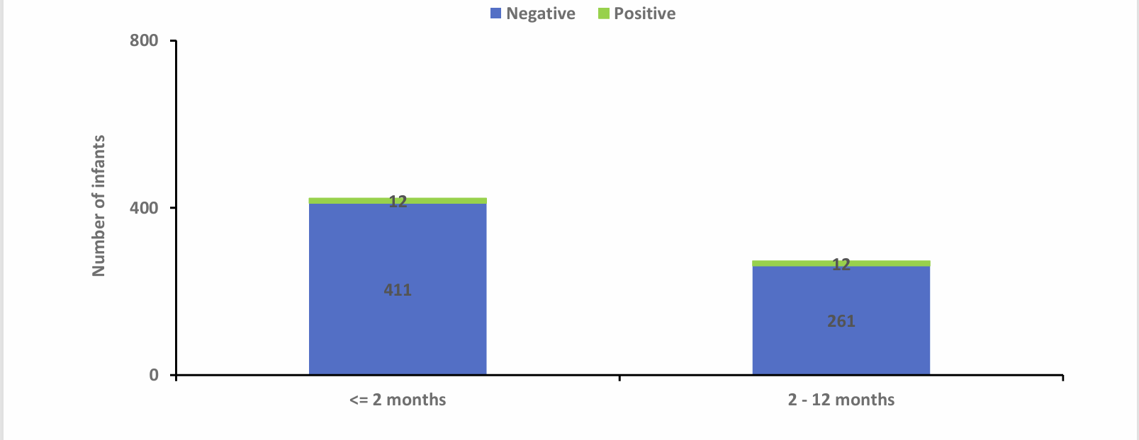

PMTCT_STAT and PMTCT-ART
PMTCT Testing Cascade
New ANC Clients
Indicator | DATIM_Indicator | Element Modality
PMTCT_STAT(DENOM) TA | PMTCT_STAT_D_TA_Age_Sex | Denominator

Known HIV Status at ANC1
Indicator | DATIM_Indicator | Element Result Group
PMTCT_STAT(NUM) TA | PMTCT_STAT_N_TA_Age_Sex_KnownNewResult | Known Positives, New Positives, New Negative, Recent Negatives

HIV Positive at ANC1
Indicator | DATIM_Indicator | Element Result Group
PMTCT_STAT(NUM) TA | PMTCT_STAT_N_TA_Age_Sex_KnownNewResult | Known Positives, New Positives,

ON ART
Indicator | DATIM_Indicator | Element Modality
PMTCT_ART TA | PMTCT_ART_N_TA_Age_NewExistingArt_Sex_HIV | New on ART, Already on ART

Known Positive at ANC1
Indicator | DATIM_Indicator | Element Result Group
PMTCT_STAT(NUM) TA | PMTCT_STAT_N_TA_Age_Sex_KnownNewResult | Known Positives
New Positives at ANC1
Indicator | DATIM_Indicator | Element Result Group
PMTCT_STAT(NUM) TA | PMTCT_STAT_N_TA_Age_Sex_KnownNewResult | New Positives

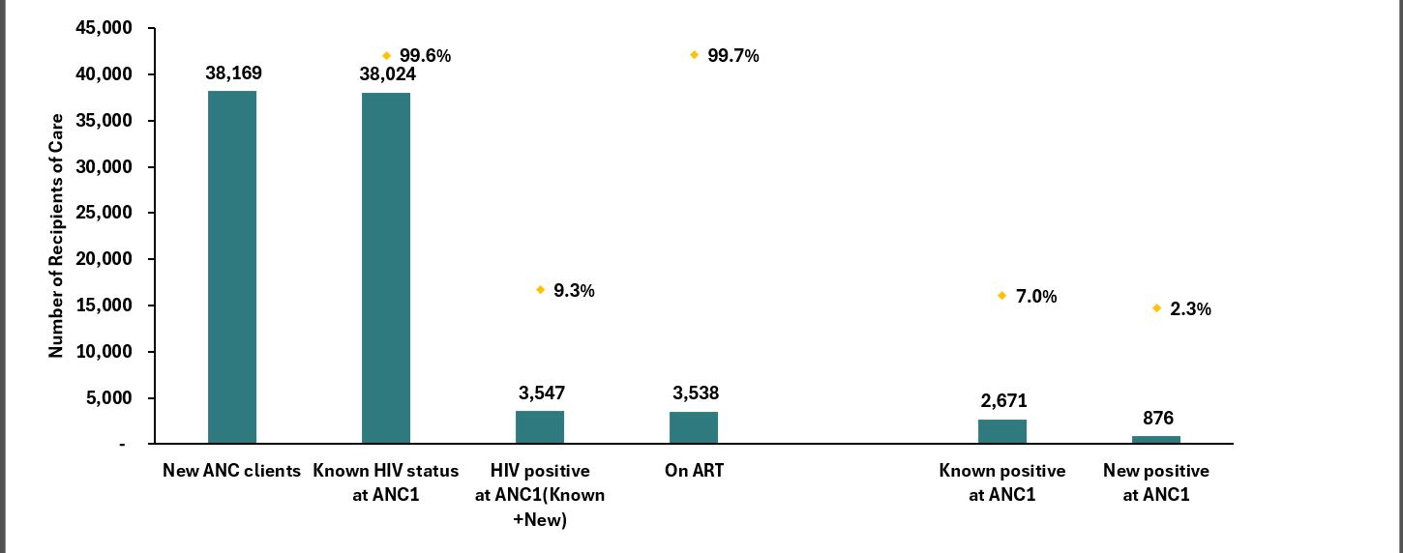

PREP_NEW Pregnant and Breast-feeding women
Trends in PREP initiations among pregnant and Breast feeding mothers – show separate trends for pregnant and breast feeding women
Pregnant women
Indicator | DATIM_Indicator | Element Modality
PrEP_NEW TA | PrEP_NEW_N_TA_Pregnant_Breastfeeding | Pregnant

Breast feeding women
Indicator | DATIM_Indicator | Element Modality
PrEP_NEW TA | PrEP_NEW_N_TA_Pregnant_Breastfeeding | Breast feeding

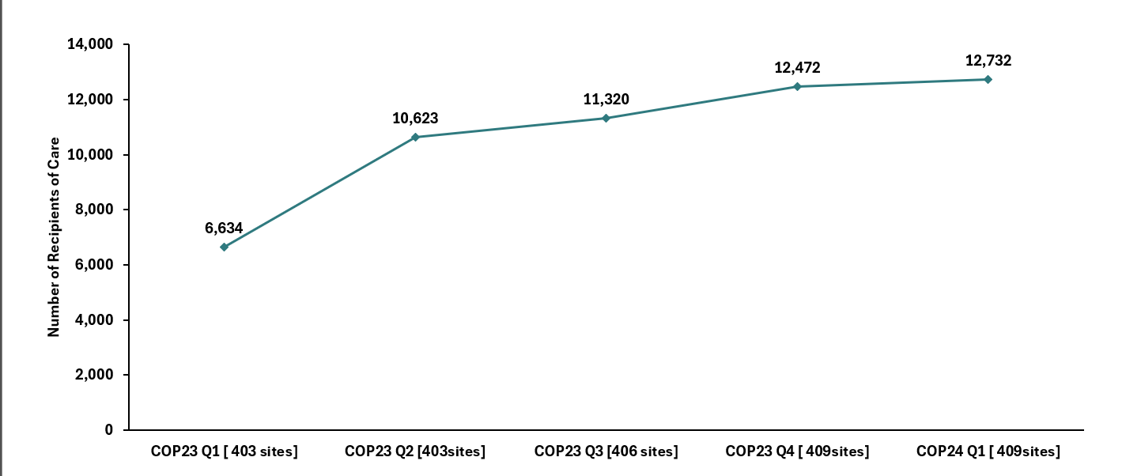

PrEP initiations by Age
Indicator | DATIM_Indicator | Element Modality | Element Age
PrEP_NEW TA | PrEP_NEW_N_TA_Pregnant_Breastfeeding | Pregnant, Breastfeeding | Age groups

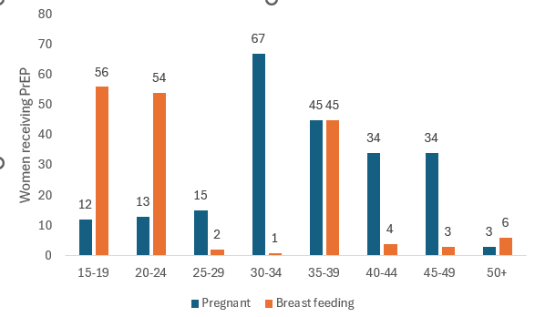
PrEP initiations by province
Indicator | DATIM_Indicator | Element Modality
PrEP_NEW TA | PrEP_NEW_N_TA_Pregnant_Breastfeeding | Breast feeding, Pregant

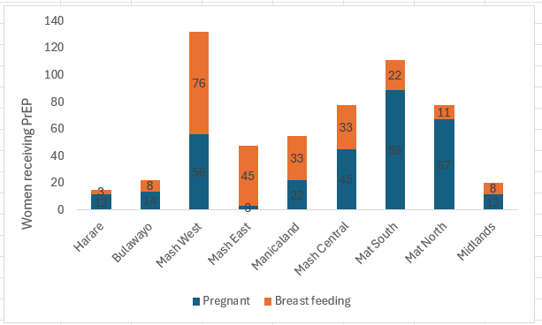

TX_CURR
TX_CURR Trends
TX_CURR
Indicator | DATIM_Indicator
TX_CURR TA | TX_CURR_N_TA_Age_Sex_HIVStatus

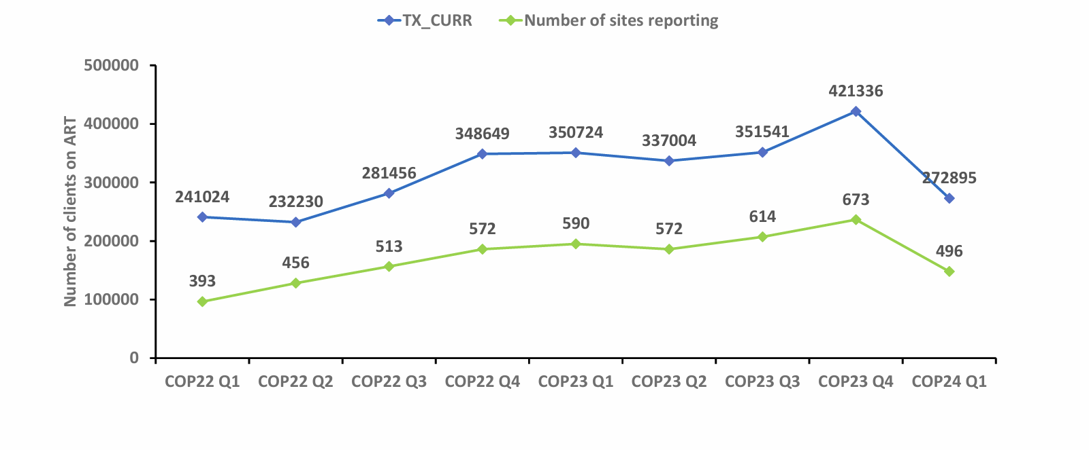
TX_CURR by province
Indicator | DATIM_Indicator
TX_CURR TA | TX_CURR_N_TA_Age_Sex_HIVStatus

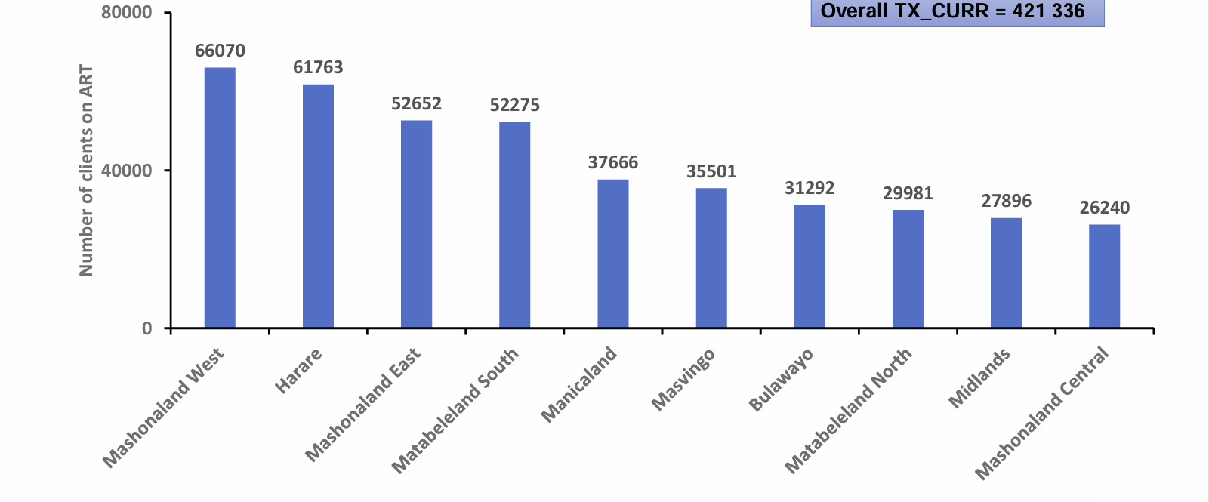
TX_CURR Multimonth dispensing by province
Indicator | DATIM_Indicator | Element Modality
TX_CURR TA | TX_CURR_N_TA_Age_Sex_ARVDispense_HIVStatus | ARV Dispensing Quantity - 3 to 5 months, ARV Dispensing Quantity - Less than 3 months, ARV Dispensing Quantity - 6 or more months

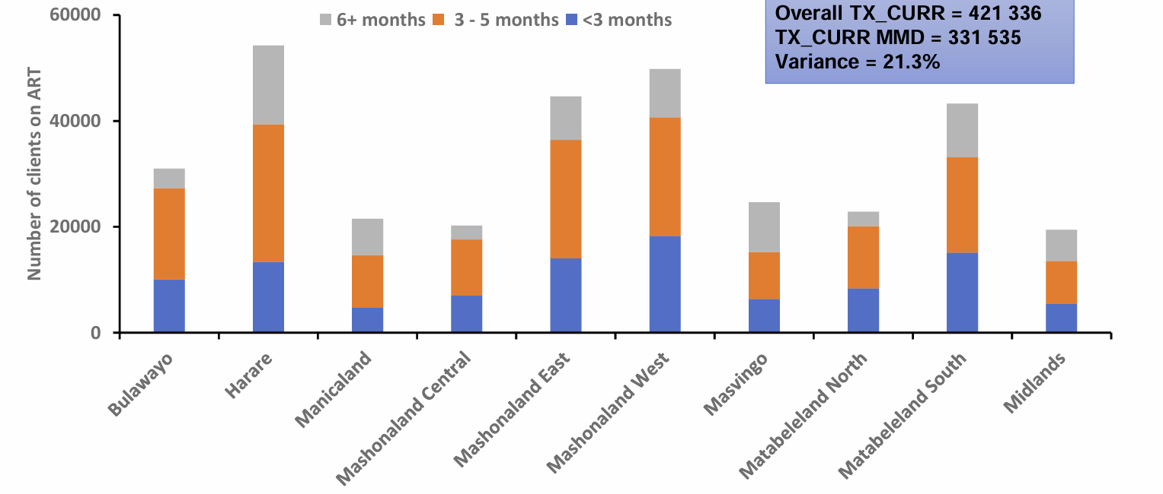
TX_CURR by Age and Sex
Indicator | DATIM_Indicator | Element Gender | Element Age
TX_CURR TA | TX_CURR_N_TA_Age_Sex_HIVStatus | Female, Male | Age groups

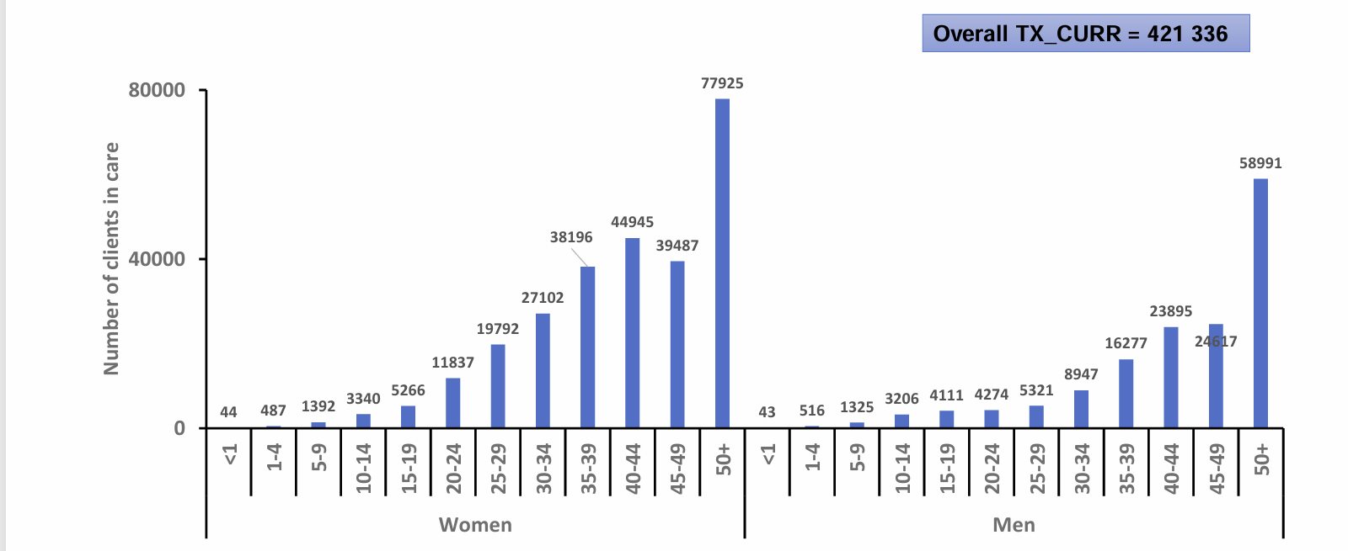

TX_ML
TX_ML Trends
Indicator | DATIM_Indicator | Element Modality
TX_ML TA | TX_ML_N_TA_Age_Sex_ARTNoContact_HIVStatus | Interruption in Treatment, Died, Refused/Stopped ART, Transferred Out

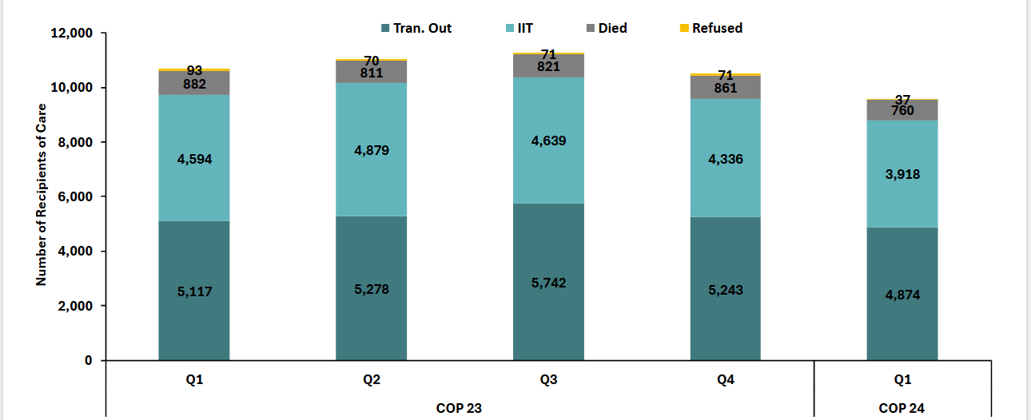

TX_ML by province
Indicator | DATIM_Indicator | Element Modality
TX_ML TA | TX_ML_N_TA_Age_Sex_ARTNoContact_HIVStatus | Interruption in Treatment, Died, Refused/Stopped ART, Transferred Out
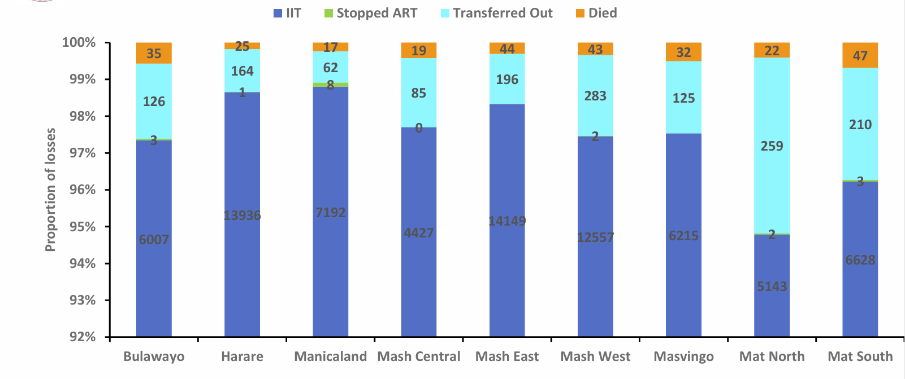

TX_ML by Age/Sex
Indicator | DATIM_Indicator | Element Modality | Element Age | Element Gender
TX_ML TA | TX_ML_N_TA_Age_Sex_ARTNoContact_HIVStatus | Interruption in Treatment, Died, Refused/Stopped ART, Transferred Out | Age groups | Female, Male

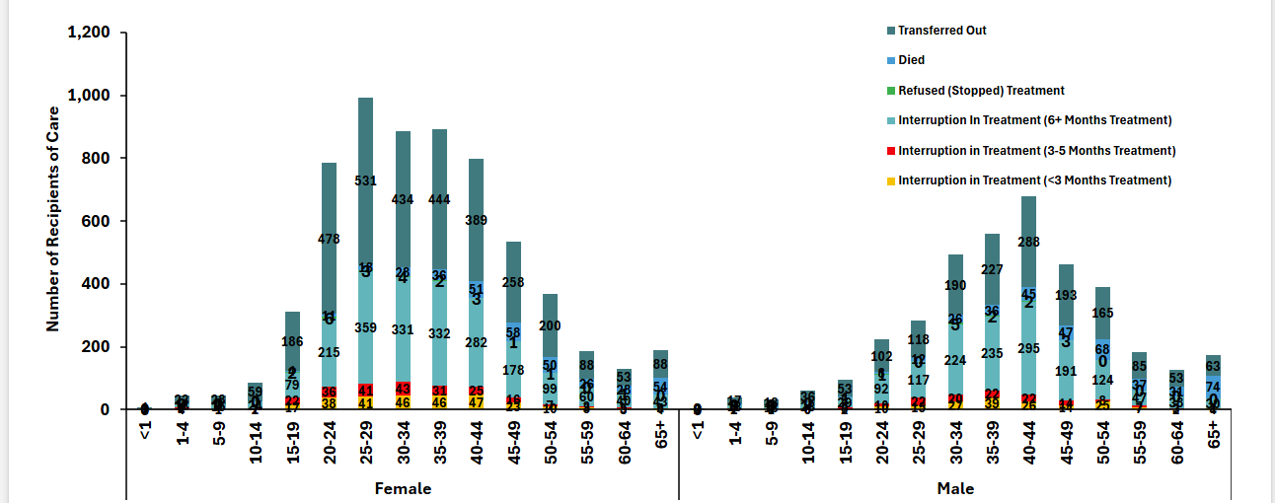

TX_PVLS
VL Cascade
Clients on ART
Indicator | DATIM_Indicator
TX_CURR TA | TX_CURR_N_TA_Age_Sex_HIVStatus

Clients with documented VL
Indicator | DATIM_Indicator
TX_PVLS(DENOM) TA | TX_PVLS_D_TA_Age_Sex_HIV

Clients with Suppressed VL
Indicator | DATIM_Indicator
TX_PVLS(NUM) TA | TX_PVLS_N_TA_Age_Sex_HIV

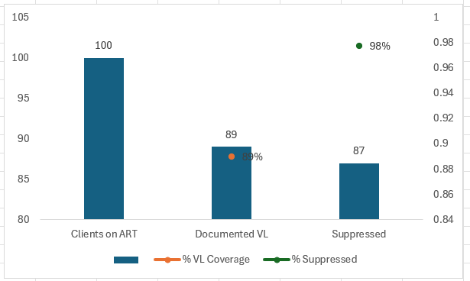

VL Coverage Trends
Clients on ART by quarter
Indicator | DATIM_Indicator
TX_CURR TA | TX_CURR_N_TA_Age_Sex_HIVStatus

Clients with documented VL by quarter
Indicator | DATIM_Indicator
TX_PVLS(DENOM) TA | TX_PVLS_D_TA_Age_Sex_HIV

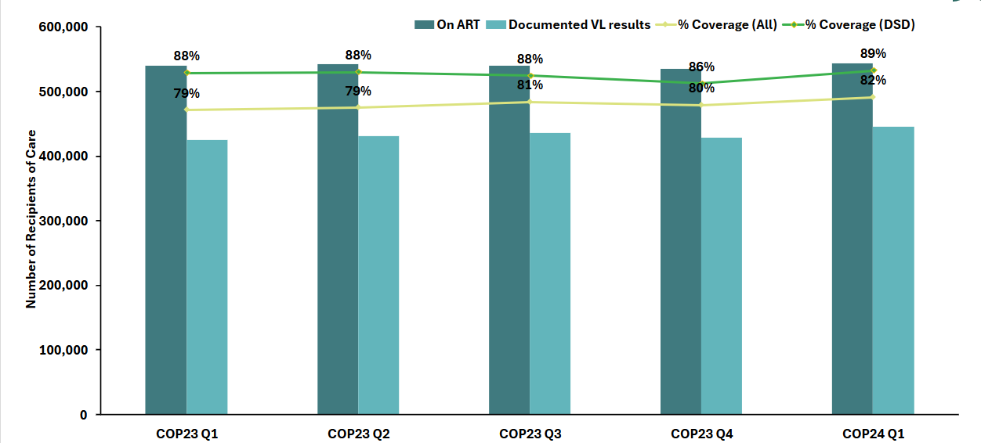

VL Coverage by province and district
Clients on ART
Indicator | DATIM_Indicator
TX_CURR TA | TX_CURR_N_TA_Age_Sex_HIVStatus

Clients with documented VL
Indicator | DATIM_Indicator
TX_PVLS(DENOM) TA | TX_PVLS_D_TA_Age_Sex_HIV

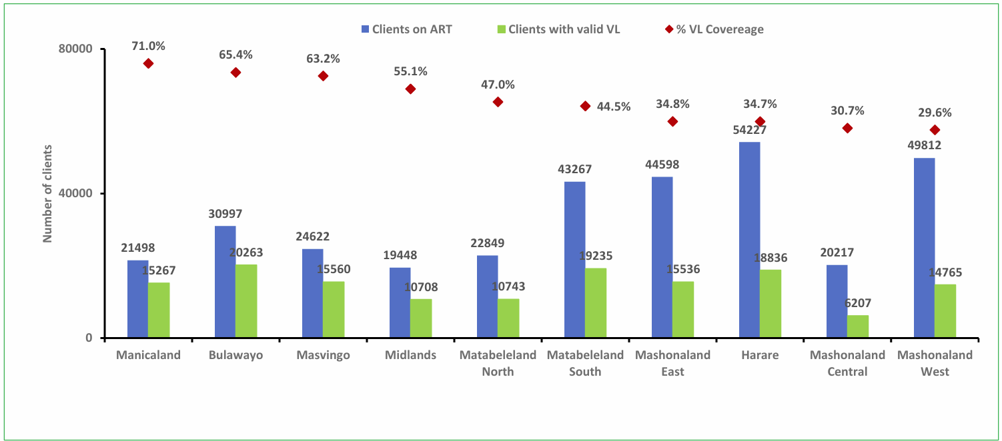

Trends in VL Suppression
Clients with documented VL
Indicator | DATIM_Indicator
TX_PVLS(DENOM) TA | TX_PVLS_D_TA_Age_Sex_HIV

Clients with Suppressed VL
Indicator | DATIM_Indicator
TX_PVLS(NUM) TA | TX_PVLS_N_TA_Age_Sex_HIV

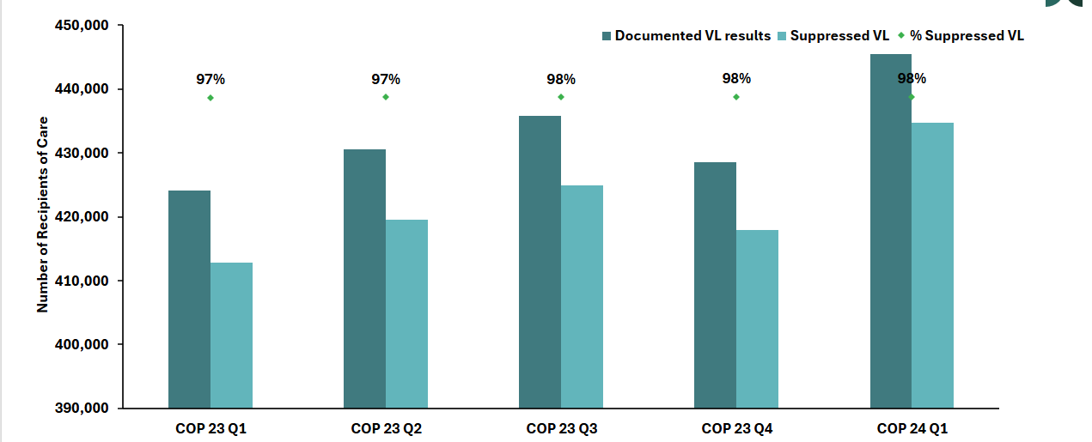

VL suppression by province and district
Clients with documented VL by province and district
Indicator | DATIM_Indicator
TX_PVLS(DENOM) TA | TX_PVLS_D_TA_Age_Sex_HIV

Clients with Suppressed VL province and district
Indicator | DATIM_Indicator
TX_PVLS(NUM) TA | TX_PVLS_N_TA_Age_Sex_HIV

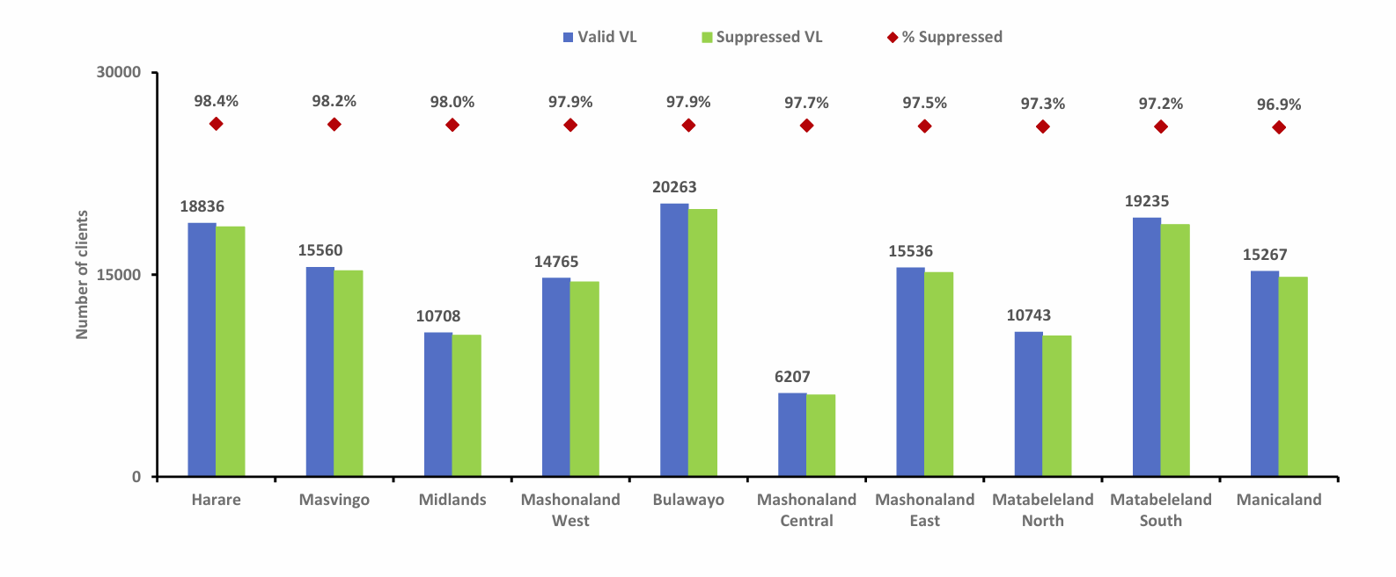
VL Coverage by age and sex
On ART
Indicator | DATIM_Indicator | Element Gender | Element Age
TX_CURR TA | TX_CURR_N_TA_Age_Sex_HIVStatus | Female, Male | Age groups

Documented VL
Indicator | DATIM_Indicator | Element Gender | Element Age
TX_PVLS(DENOM) TA | TX_PVLS_D_TA_Age_Sex_HIV | Female, Male | Age groups

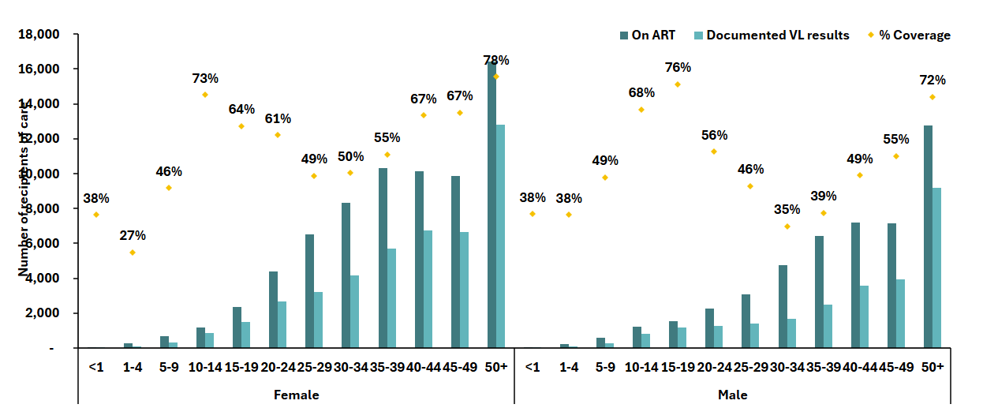
VL suppression age and sex
Documented VL
Indicator | DATIM_Indicator | Element Gender | Element Age
TX_PVLS(DENOM) TA | TX_PVLS_D_TA_Age_Sex_HIV | Female, Male | Age groups

Clients with Suppressed VL
Indicator | DATIM_Indicator | Element Gender | Element Age
TX_PVLS(NUM) TA | TX_PVLS_N_TA_Age_Sex_HIV | Female, Male | Age groups

